Dryer Lint Paper-Making
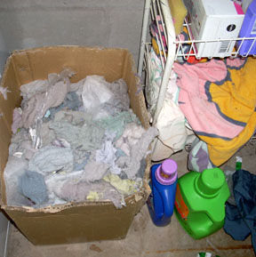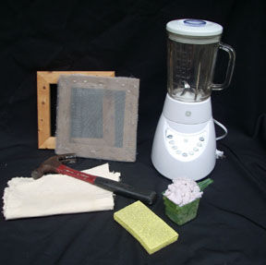
Have you ever wondered what you can do with all that dryer lint that accumulates after you do your laundry?
In this Instructable I am going to show you how you can use lint to make paper.
Materials you will need:
Lint
Warm water
Wood frames (you can use two wood picture frames) or cardboard
Window screening
Scissors to cut the screening
Staple gun or hammer and nails
Tub
Blender
Fabric

Step 1: First Soak the Lint

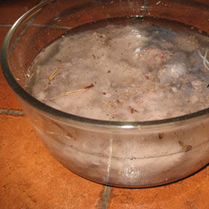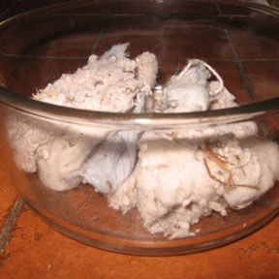
The first step is to soak the lint in warm water for at least 30 minutes. This helps the lint to break down so that it's easier to blend during the next step. You should soak the lint in warm water until it becomes saturated and soft, the longer the better. If you have the time, then soak the lint over-night. You can also add other ingredients to be soaked in the water like shredded paper or leaves. Both paper and leaves will give the lint paper more body in the end.

Step 2: Make the Deckle and the Mold

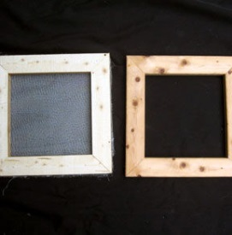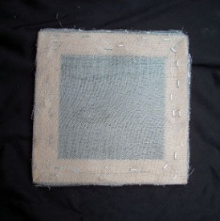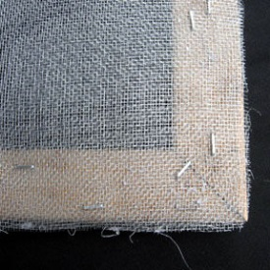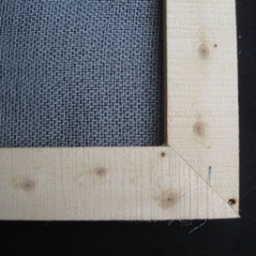

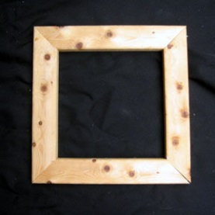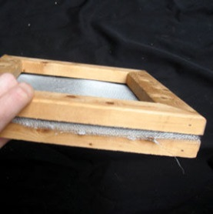
While the lint is soaking you can make the deckle and the mold, integral parts of paper making. The mold is a frame with screening (like window screening) in the center that is used to catch the lint. The deckle is a frame without any screening. It is placed on top of the mold and gives the paper smooth edges.
Both should be the same size.
The deckle and the mold are used together: the mold on the bottom (screen facing up) and the deckle on top.
You can choose to make the frames with old wood pictures frames, or even cardboard covered in duct tape (so that it is water proof.)
Make sure the screening is pulled tightly across the frame.
To add the screening to the mold, use a staple gun or nails.

Step 3: Blending the Lint

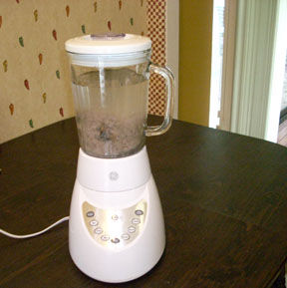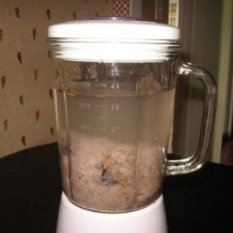
The next step is to liquefy the lint in a blender.
Scoop one cup of lint and put it in the blender, then add water to fill the rest of the blender until it is close to the top.
There should be more water than lint in the blender. Blend until it is smooth and mushy.

Step 4: Pour the Mush in a Tub

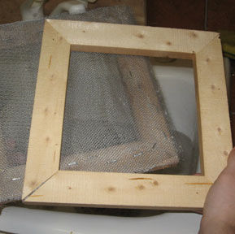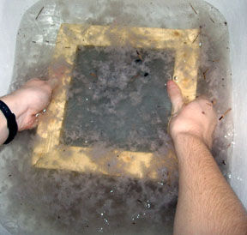

After the lint is blended to a fine mush, pour it into a tub. I used my kitchen sink. You can also use baby bathtubs, large pans or buckets. Just keep in mind that the mold and the deckle will need to be able to fit in whatever you choose to use as your tub.
Keep blending and pouring mush into the tub until there are a few inches of mush.
Then it is time to use the deckle and the mold. Place them into the water with the mold on the bottom (screen side up) and the deckle on top.

Step 5: Sifting

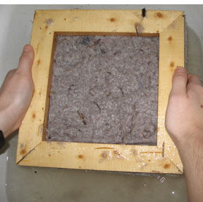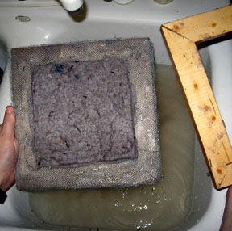

Sift the mold and the deckle in the water until enough lint has been evenly collected onto the screening.
Remove the mold and the deckle from the water and let it drip for a few seconds. Then remove the deckle.

Step 6: Off the Mold and onto the Fabric

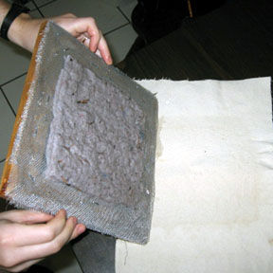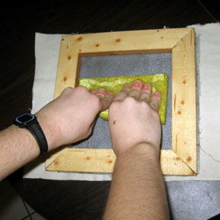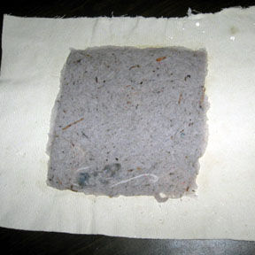
Now place the mold face down onto a piece of fabric so that the lint is on the fabric.
Use a sponge to press the lint onto the fabric and to soak up excess water.
Then slowly lift the mold off of the fabric so that the lint is left.

Step 7: Last Step

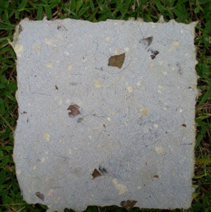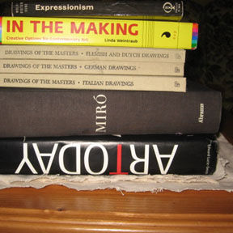
If you are making multiple pieces of paper, then place another piece of fabric on top of the lint and repeat the process. Once you are finished you can add books on top of the stack of fabric to flatten out the paper and press out the water.
After several hours (mine took about 6 hours indoors) remove the books and allow the lint to completely dry.
Once the lint is dry, you have your very own Lint Paper!

